Lesson Plan
Unit/Topic: Connecting colours-Part 1 Date: 14th May 2014

Key Learning Area: The Arts Year Level: Foundation
Outcomes:

LESSON STRUCTURE:
Time | Introduction (Set): | Teaching Approaches
1.30pm  -  1.35pm | - Advise students that in this lesson they:  - will begin to explore 3 colours used in art-red, yellow and blue;  - will think about what might be in their home, fridge, rooms, that are these colours;  - Will work in groups of 5 to find pictures in magazines in ONLY the 3 colours, red, yellow and blue  - Will begin to make their own colour wheel  - Show students red, yellow and blue samples  - Can students name the colours?  - Students:  - Share something they know in red, yellow and blue | Whole class seated on the floor, facing the teacher  Whole class sharing of information  Large samples to show students  Students put their hand up-no calling out

Time | Main Content: | Teaching Approaches
1.35pm  -  1.55pm  1.55pm  -  2.00pm  2.00pm  -  2.15pm | - Students advised they will work in groups to:  - Use classroom magazines to find, cut out and glue objects in only red yellow and blue, onto cardboard templates-“Our Red, yellow and blue Poster”  - Students are given 1 minute, to get their pencil cases, be seated at their desk, and choose only the 3 colours:-1 red; 1 yellow, 1 blue.  - Groups write red, yellow, blue on cardboard templates before locating pictures/drawing images  - Pictures are to be glued under correct colour label  - Students may also draw objects that come in red, yellow and blue  - Students regroup as a whole class seated on the floor with their poster, for group sharing  - Discuss with students that these 3 colours are special/unique  QUESTIONS:  - Why might each of the 3 colours – red, yellow and blue, be special/unique  - These 3 colours have a special name. Does anyone know what this special name is?  COLOUR WHEEL COLOURING IN  - Advise students they will begin colouring in their own colour wheel  - Using a predesigned colour wheel, explain the process to students:  -STEP 1: Students write their name on the back of their colour wheel  -STEP 2: Students colour:  -the number 1 triangle, YELLOW  -the number 3 triangle, RED  -the number 5 triangle, BLUE  -STEP 3: Students to colour in their colour wheel neatly  Ensure students understand the process/requirements of the colour wheel through questioning e.g.  Q. what is the first thing you need to do?  Q. What colour will you use in triangle number 1  Q. What colour will you use in triangle number 2  Q. What colour will you use in triangle number 3  ANY QUESTIONS? | Students work in groups of 4-5  Use teacher cardboard template to model process  Teacher hands out lead pencils; glue sticks and scissors  Students have 15 minutes to complete their “Our Red, Yellow, and Blue Poster.”  Clarify student understanding – Question: Do we find pictures in green/pink?  Do we glue a blue picture, under the red label?  A. These colours cannot be made by mixing two other colours (Trowbridge, 2013).  A. Primary (main; only one of)  Develop student knowledge of special/unique through questioning  Ensure colour wheels are ready for students  Reiterate students are to use only the 3 colours of the lesson  Use template to model student requirements.  Display a pre-coloured wheel with yellow, red and blue, through the IWB to show to students while colouring in  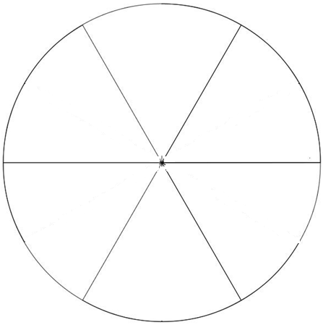  3  5  1

Time | Conclusion: | Teaching Approaches
2.15pm  -  2.19pm | - Students are given 1 minutes to:  - pack up pencils  - place colour wheels on teachers desk  - be seated quietly on the floor in front of the teacher  - Students share something they have learnt in the lesson  - Questions:  - What colours did we talk about today?  - What name was given to the 3 colours that made them special?  -Advise students of the next art lesson, which will look at more colours  EXTENTION ACTIVITIES:  1. Students who complete their colouring in can cut out the names of the colours, and stick it on the coloured triangle  Blue  Red  Yellow  2. If all students complete tasks before end of lesson and time permits, students can play a whole class game based on colours:  Red, red, red – touch your head  Blue-touch your shoe  Green – look really mean  Pink-give a wink  White – take a bite  Brown-touch the ground  Purple – draw a circle  Yellow – say hello  Black – touch your back  Grey – shout “hooray”. | Red, Yellow, Blue  Primary

Resources
(Include equipment required for class and/or for teacher preparation)
- Teacher colour wheel template
- 22 colour wheel template
- Teacher OUR RED YELLOW BLUE POSTER template
- 5 x OUR RED YELLOW BLUE POSTER templates
- Interactive whiteboard
- USB with Colour wheel; Primary colours
- Printed copies of the primary colours used
- Lead pencils
- Students’ pencil cases
- Variety of colours used in the extension song
- 22 of each colour name – red, yellow, blue
- Laptop/computer
- Scissors
- Glue sticks
- Magazines

Safety Considerations/Materials
- Ensure students respect each other’s personal space when engaging in activities/games
- Classroom safety procedures to be followed when using hazardous items e.g. scissors

Assessment
- Students will be assessed formatively, on their contribution/participation to whole class discussion and questioning
- Ability to follow guided instructions e.g. positioning of name and colours
- Ability to identify correct selection of colours

REFLECTION
- Was lesson content fun and engaging
- Do students meet expected lesson outcomes
- Was lesson content relevant to learning

REFERENCES

Teaching Ideas. (2014). Primary and secondary colours. Retrieved from http://www.teachingideas.co.uk

Trowbridge, C. (2013). Create Your Own Colour Wheel. Retrieved from http://www.teachkidsart.net/create-your-own-color-wheel-2/

